Kidney Transplantation Travel Checklist

- This is a list of things you will need when coming to the Royal Adelaide Hospital for your new kidney operation.
- Have this bag packed and keep it in your house ready to go OR keep this list on the fridge to know what to pack when you get the call.
- You will need to stay in hospital for minimum 3 days and in Adelaide for minimum 4 weeks.
- It gets very cold in winter and very hot in summer.
- Best to have loose fitting clothes because your scar could be very sore.

Clothes to Pack | Picture
- x4-7 pairs of underwear | 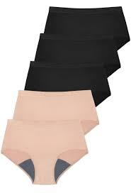  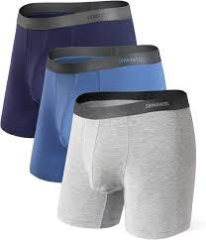
- x4-7 pairs of socks | 
- x2-3 shirts |   
- x1-2 jumpers/hoodie | 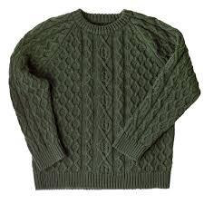
- x1-2 pair of PJ’s |   
- x1-2 pairs of loose-fitting pants/trackies | 
- x1-2 pair of loose-fitting shorts | 
- Gloves, beanie and scarf (it gets very cold in Adelaide) |   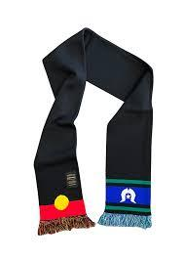  
- x1 sneakers/running shoes | 
- x1 slides/thongs | 

- Other things to pack with you that are important.
Remember to Pack | Picture
- A suitcase to put everything in | 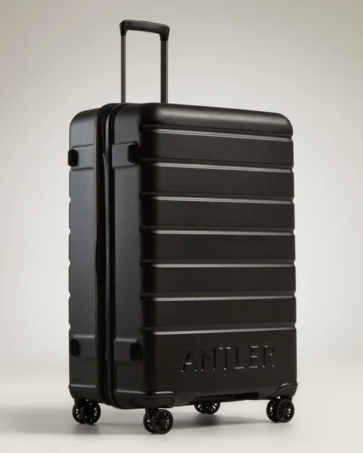
- Medications OR Webster packs | 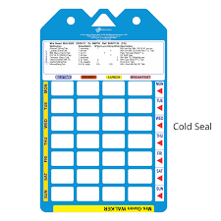
- Blood sugar machine and test strips (if you have diabetes) | 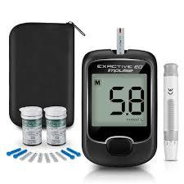
- Glasses | 
- Phone and charger |   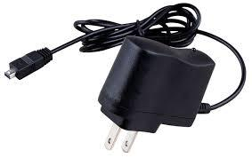
- Money and bank card |   
- Hairbrush | 
- Toiletries (some can be given to your in hospital like toothbrush and toothpaste) | 

- Things to remember for the ~4 weeks you will be staying in Adelaide.
- Do you know where you are staying (Kanggawodli or other hostel)? Do you have any accessibility requirements for your accommodation (do you need a wheelchair or walker)?
- Who is coming with you (a person that will stay with you for the whole time and support you to heal proper)?

